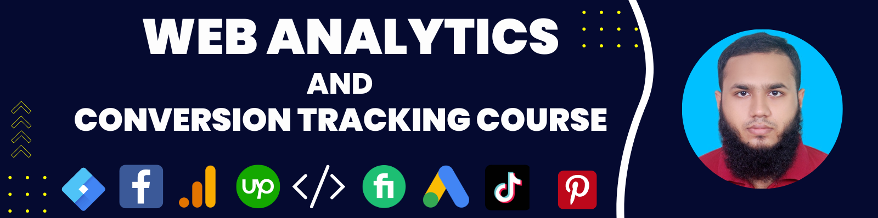

**Freelancing and Freelancing Skills**

**What is Freelancing?**

Freelancing is a type of self-employment job employed by a company or individual person, freelancers tend to work as self-employed, **delivering their services on a contract, project, or monthly basis.**

**Comparison of Freelancing between Traditional Job and Business**

| **Comparisons** | **Freelance Job** | **Traditional Job** |
| --- | --- | --- |
| **Job Place** | **Any places where internet connection available** | **In a specific place** |
| **Job Hour** | **Set by own** | **Defined by authority** |
| **Job Responsibility** | **Set by Experience** | **Defined by authority** |
| **Job Promotion** | **Level 1 - Level 2 - Top Rated and based on totally experience and earning** | **There are many metrics that may impact on job promotion** |
| **Vacation** | **Set by own** | **Need permission from boss** |
| **Job Security** | **Based Your Skill and Intellectuality- 🥰🥰😁** | **Private - 😰**  **Public - 😁🥹😭** |
| **Salary** | **Maximum MashaAllah - I reached to 6 Figure amount in the Second month of my freelancing life 😁** | **Sometimes MashaAllah 🥰**  **Sometimes Nauzubillah🥹** |

**What are The Freelancing Skills**

* Web Design
* Web Development
* Graphics Design
* Digital Advertising
* Web Analytics and Conversion Tracking

**Web Analytics and Conversion Tracking**

**Web Conversion Tracking**

* To Measure Digital Advertising Results
* To Retarget or Remarket Audience
* To Remarket Dynamically

**Web Analytics**

* To Analyse Those Tracked Data To Answer Some Questions

**Like,**

* What are my best-selling products?
* What are my top products by revenue?
* Revenue by the city this month?
* What are my Ecommerce purchases by Marketing Platform?
* Which Language do people use most?
* What are the top countries or cities by revenue in this year
* Which marketing channel generates most sales?

**How Does Basically Digital Advertising Campaigns Work And Relate with Web Conversion Tracking and Analytics?**

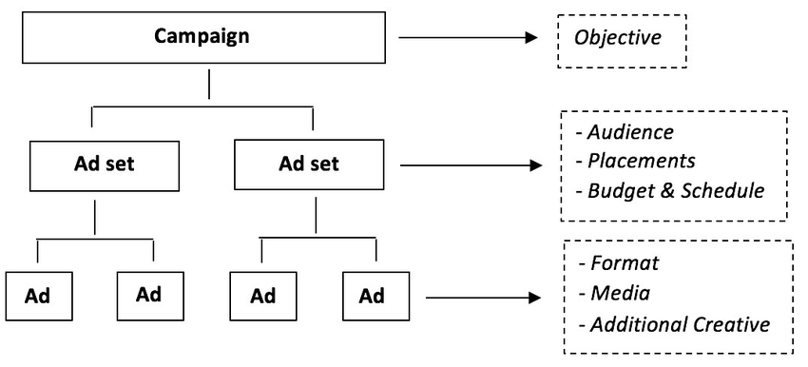

**Competition of Web Analytics and Conversion Tracking Skills**

**Verify you facebook account before creating business manager**

**Follow the link -** <https://www.facebook.com/id/hub/>  
  
**To change profile name**: <https://accountscenter.facebook.com/profiles/>

**Fiverr**

**Upwork**

**Out of Market Place**

**Support —**

**Permanent (exact solution) - Google, Youtube, ChatGpt and Internal Group**

**Not Permanent - Finally Our Official Support**